**Data Analysis of Earthquake Dataset**

**Team Members:**

1. **Ashoka Chakra Varthy**
2. **Tejas Reddy Vepala**
3. **Meghana Kurapati**

**Dataset Description:**

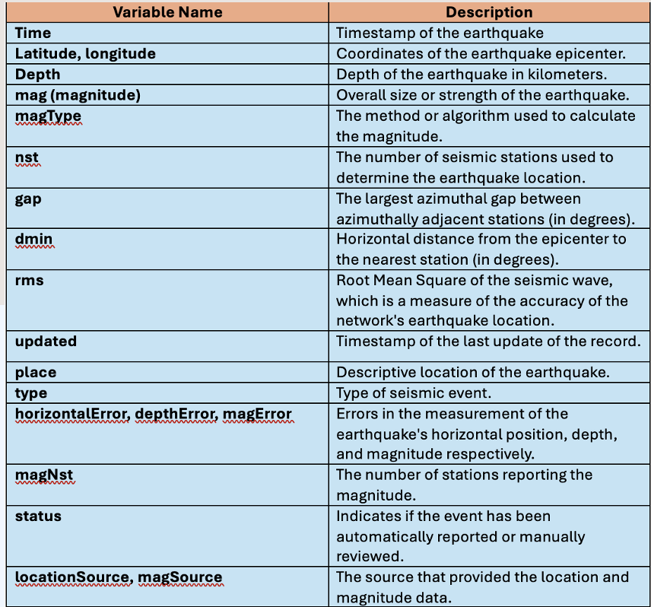

Creating a Cluster:

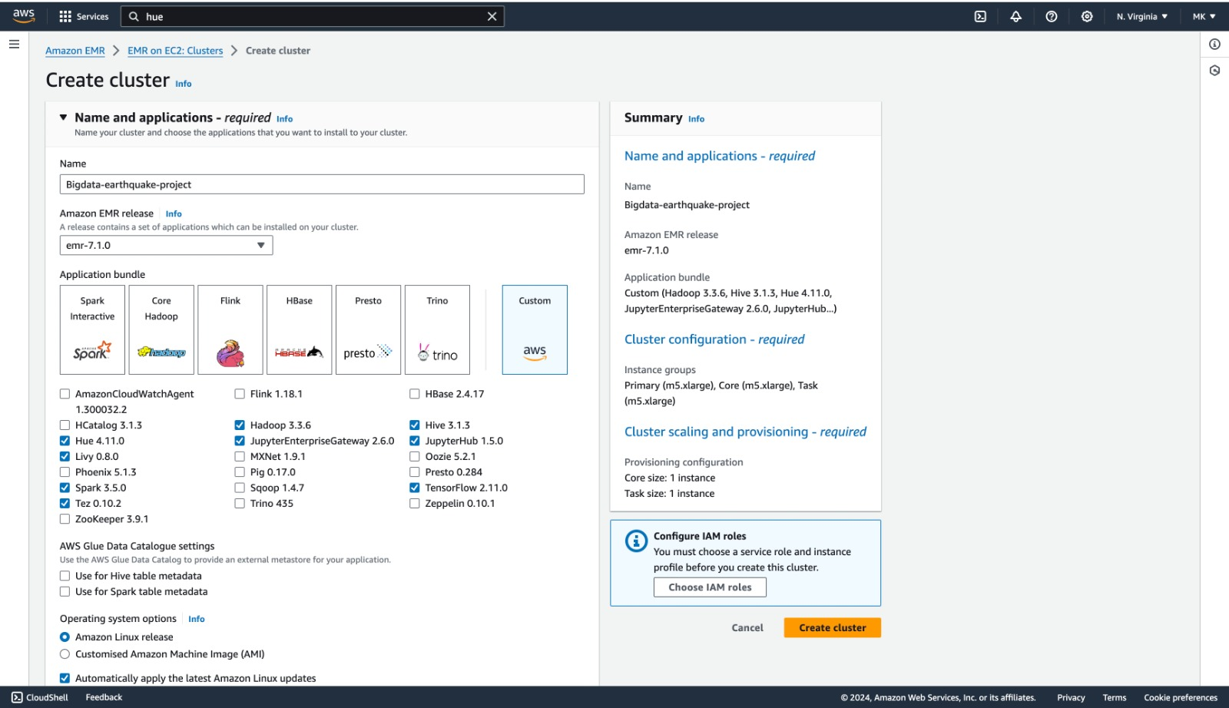

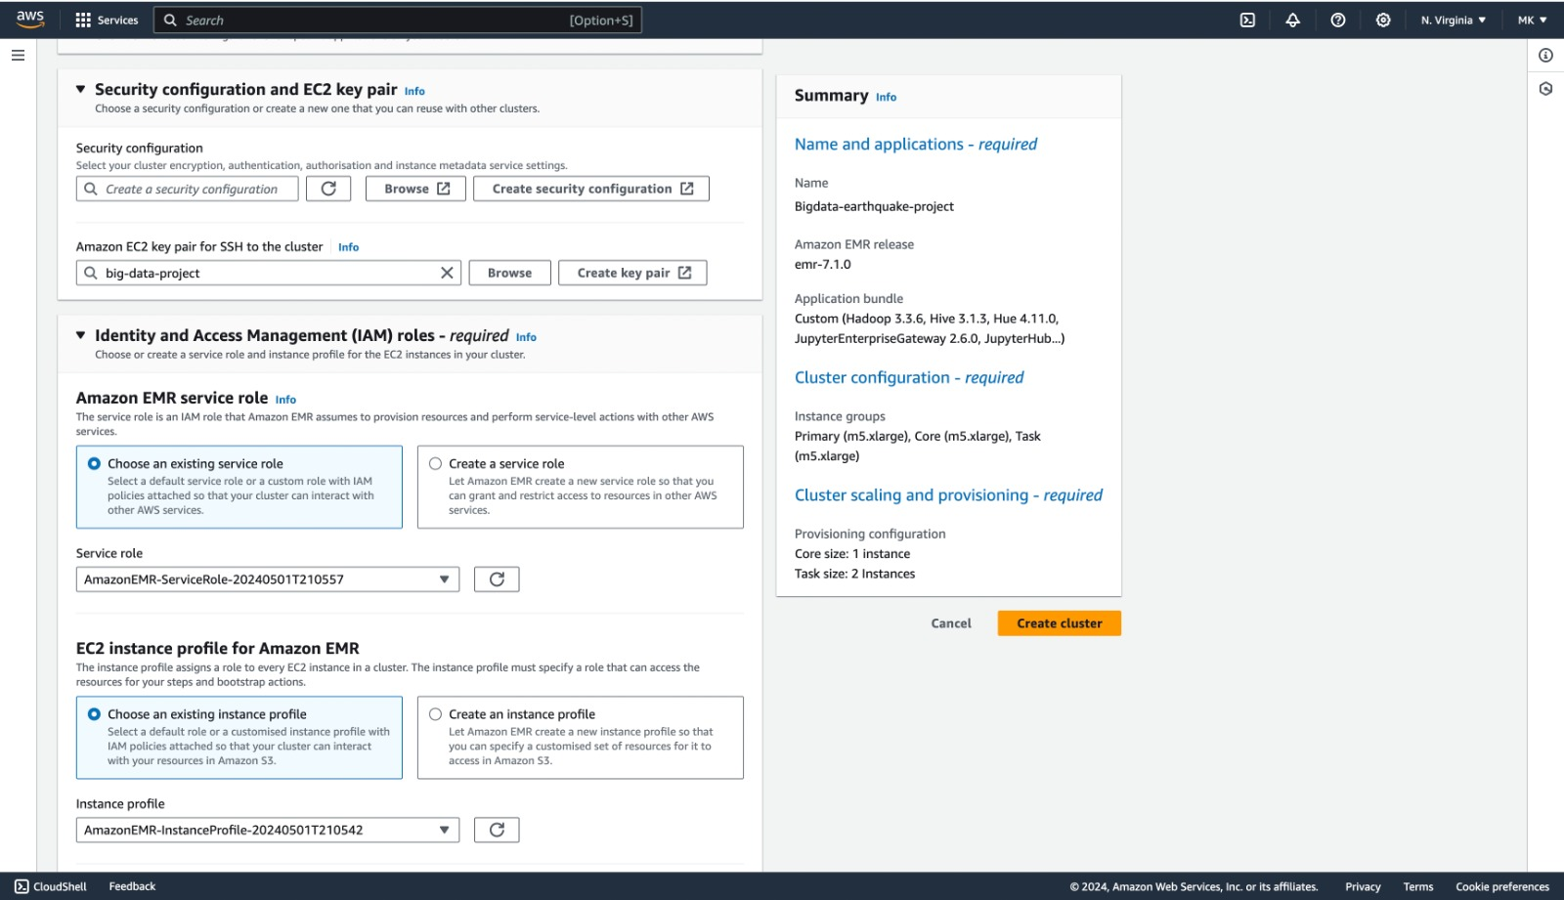

Under security configuration and EC2 key pair, we can either create a new key pair or we can select the existing keypair.

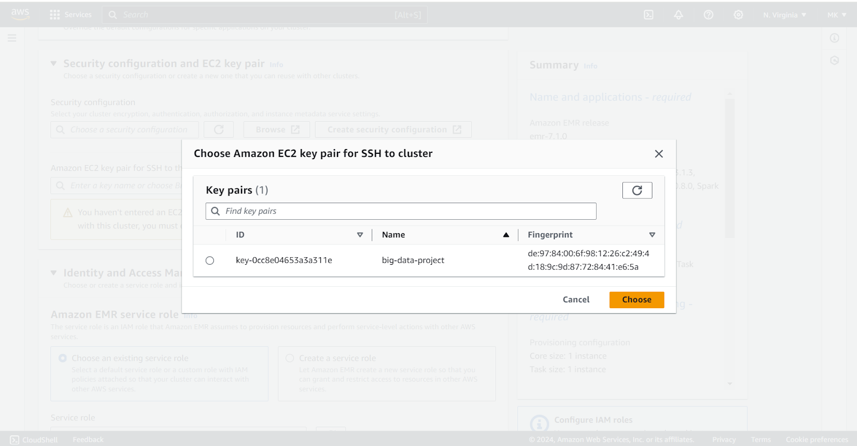

* If we are creating a new keypair, navigate to keypairs (EC2 feature)
* Enter the name of the  keypair and download the .pem file (.pem is a certificate to authenticate the EMR from the terminal)
* Once the .pem file is downloaded, make sure to restrict the .pem file, so that we can use the certificate to access the EMR

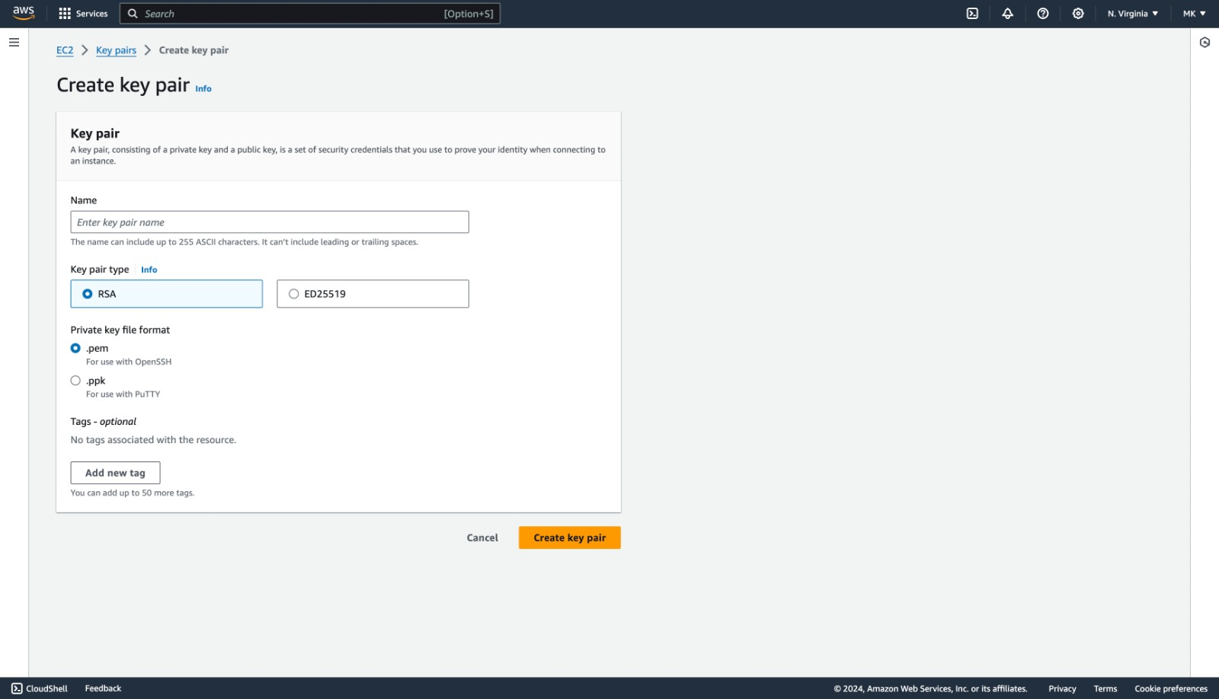

**Setting up S3 bucket**

* We can either add .csv files to the already existing s3 bucket or we create a new s3 bucket and upload the files

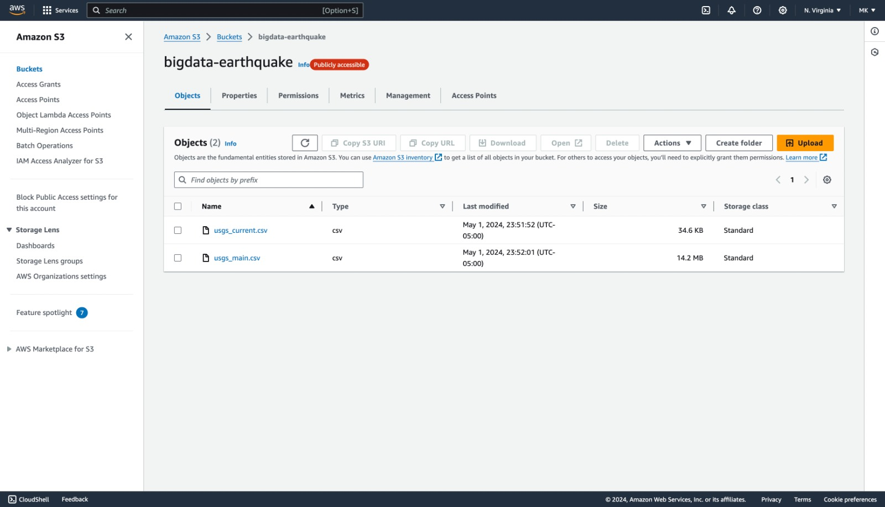

Accessing EMR through Terminal

* To access AWS EMR through terminal, we need to authenticate using download keypair

ssh -i /path/to/your-key.pem hadoop@master-node-public-dns

Replace /path/to/your-key.pem with the path EC2 key pair private key file.

Replace master-node-public-dns with the actual public DNS or IP of the master node.

**HIVE Setup**

* We can run hive queries by entering **HIVE** in terminal.

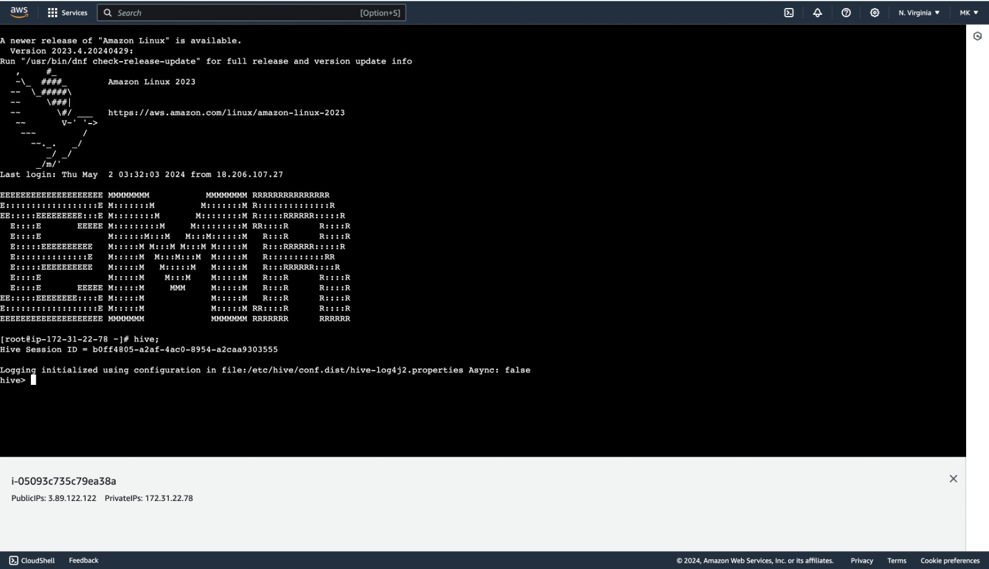

Creating table earthquake_main:

CREATE TABLE earthquake_main(

    `time` string,

    latitude float,

    longitude DOUBLE,

    depth DOUBLE,

    mag DOUBLE,

    magType STRING,

    nst INT,

    gap DOUBLE,

    dmin DOUBLE,

    rms DOUBLE,

    net STRING,

    id STRING,

    updated string,

    place STRING,

    type STRING,

    horizontalError DOUBLE,

    depthError DOUBLE,

    magError DOUBLE,

    magNst INT,

    status STRING,

    locationSource STRING,

    magSource STRING)

ROW FORMAT DELIMITED

FIELDS TERMINATED BY ','

STORED AS TEXTFILE;

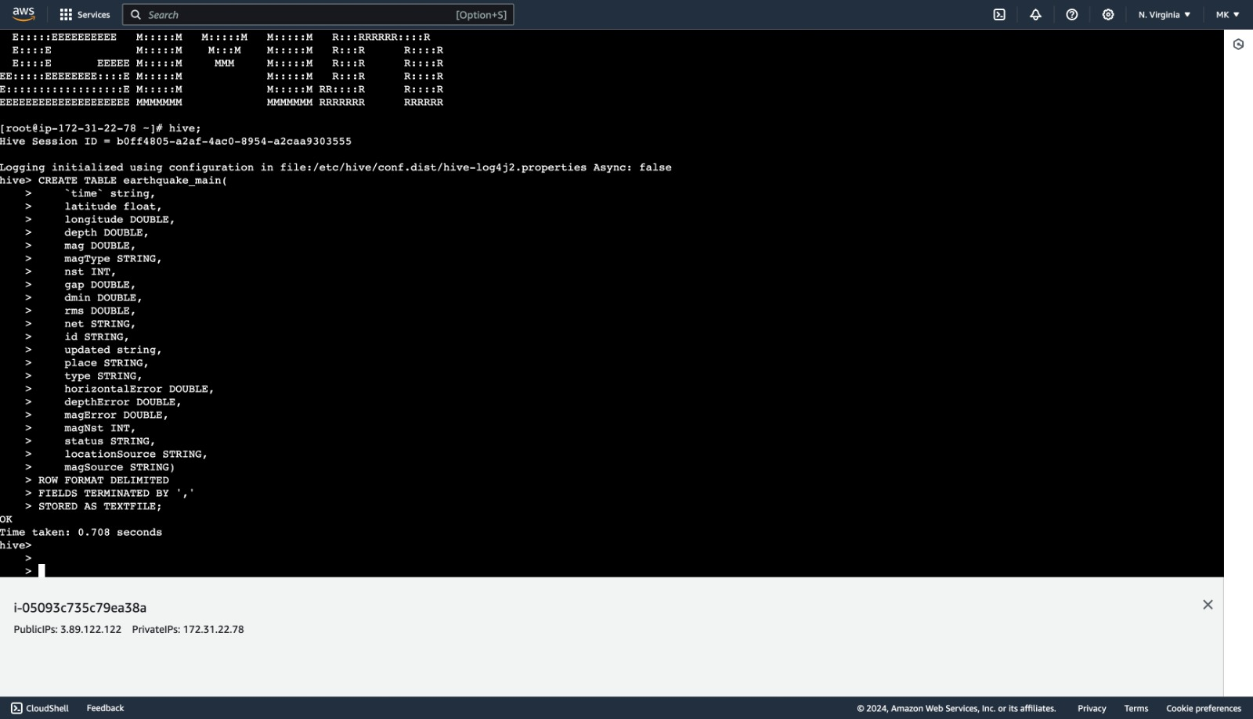

Creating table earthquake_current:

CREATE TABLE earthquake_current(

    `time` string,

    latitude float,

    longitude DOUBLE,

    depth DOUBLE,

    mag DOUBLE,

    magType STRING,

    nst INT,

    gap DOUBLE,

    dmin DOUBLE,

    rms DOUBLE,

    net STRING,

    id STRING,

    updated string,

    place STRING,

    type STRING,

    horizontalError DOUBLE,

    depthError DOUBLE,

    magError DOUBLE,

    magNst INT,

    status STRING,

    locationSource STRING,

    magSource STRING)

ROW FORMAT DELIMITED

FIELDS TERMINATED BY ','

STORED AS TEXTFILE;

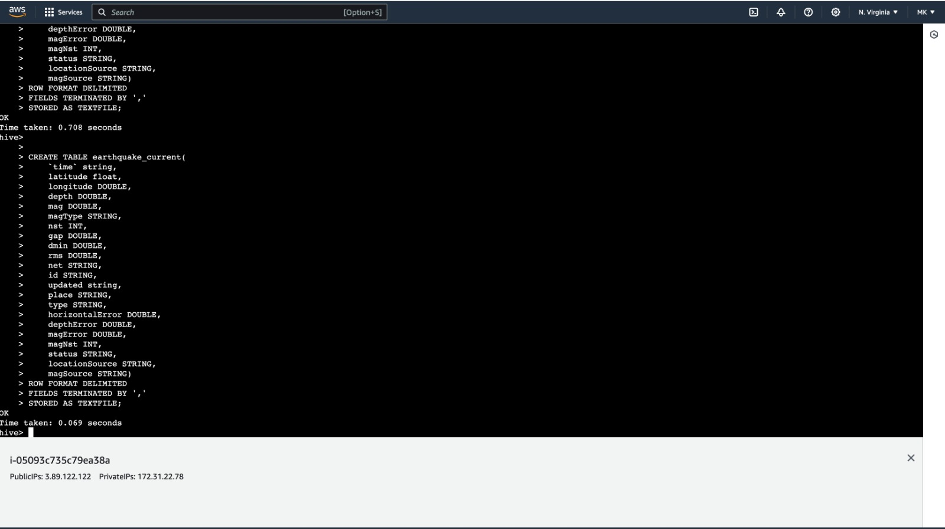

Loading the data from S3 bucket to the hive tables:

LOAD DATA INPATH 's3://bigdata-earthquake/usgs_current.csv' INTO TABLE earthquake_current;

LOAD DATA INPATH 's3://bigdata-earthquake/usgs_main.csv' INTO TABLE earthquake_main;

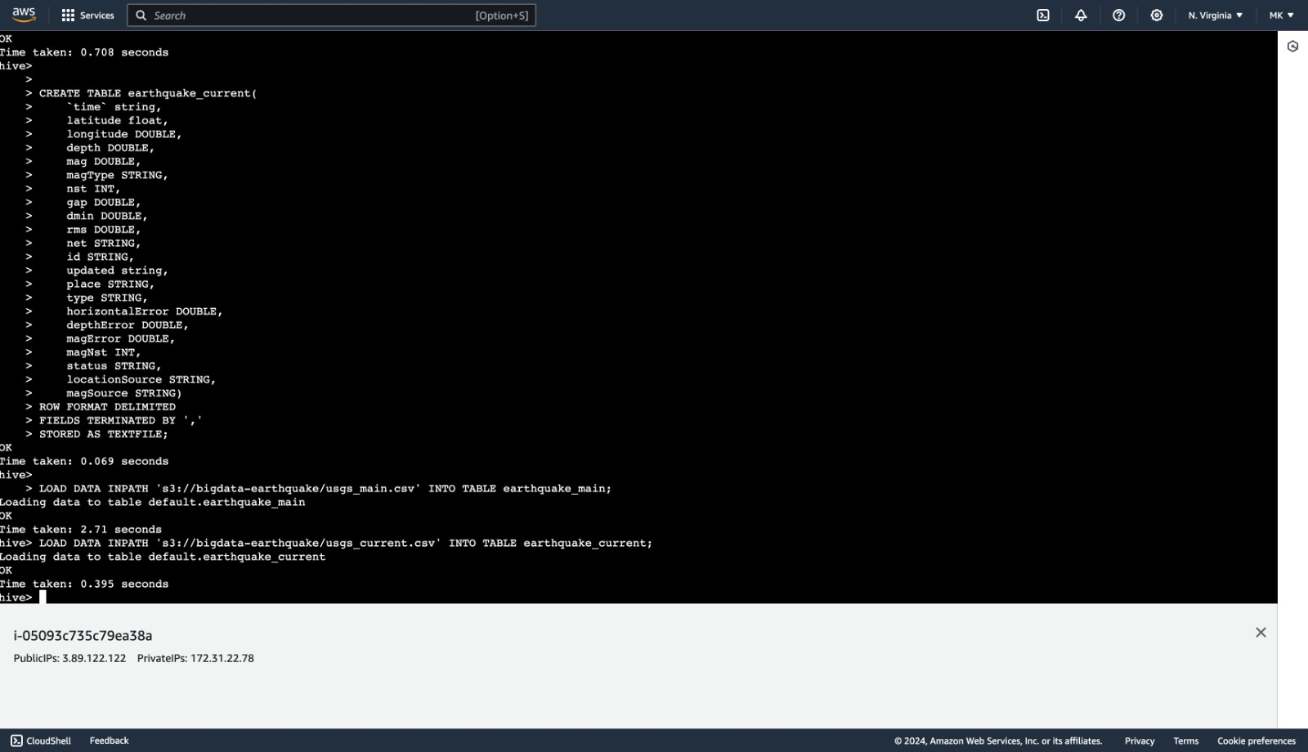

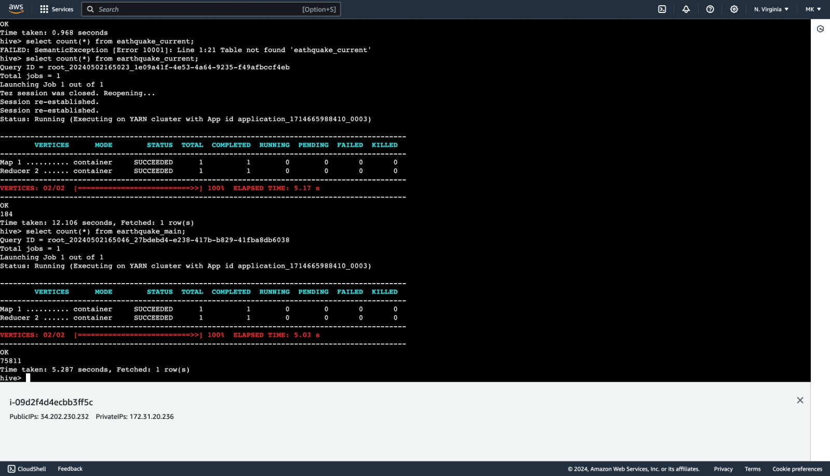

Hive Queries:

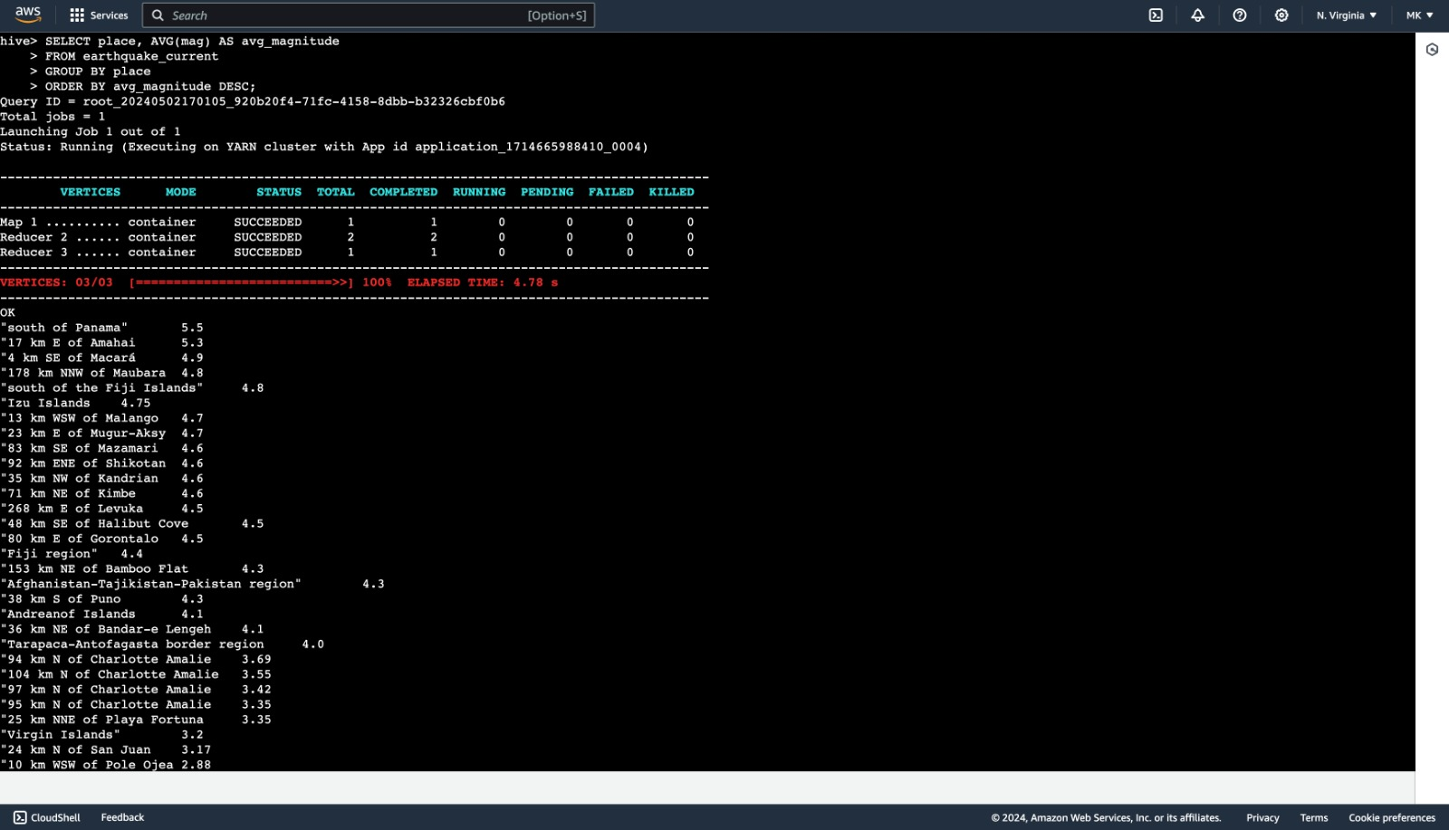

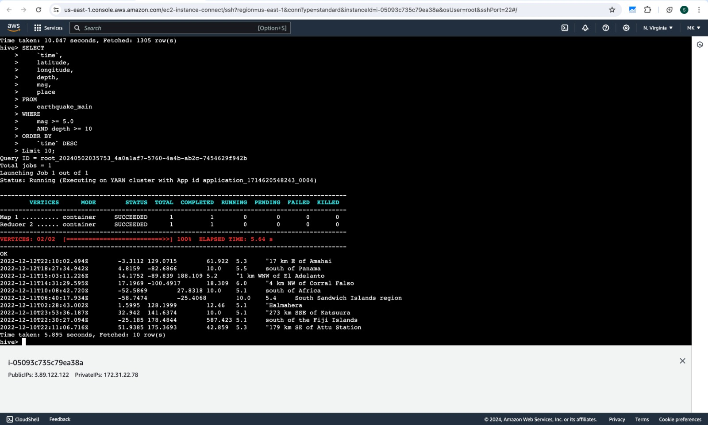

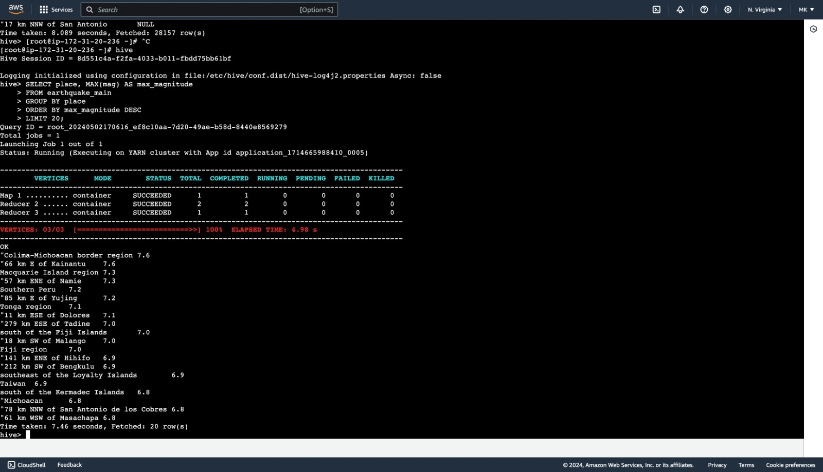

Setting Up JupyterHub:

To access the Jupyter notebook we can find the application url from the application tab in EMR

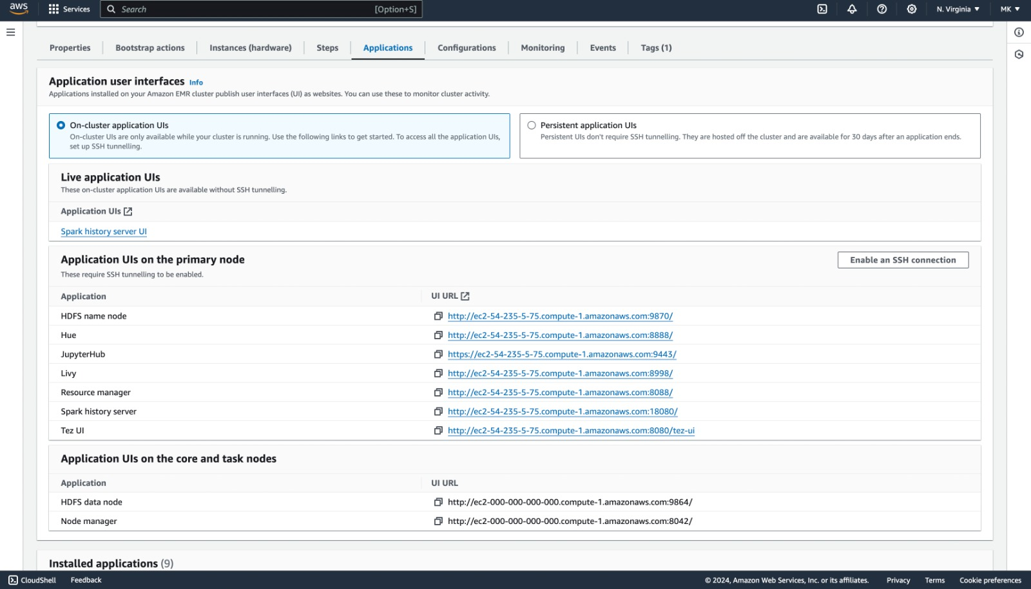

To access this url, First we need to add the rules in security groups of the master node.

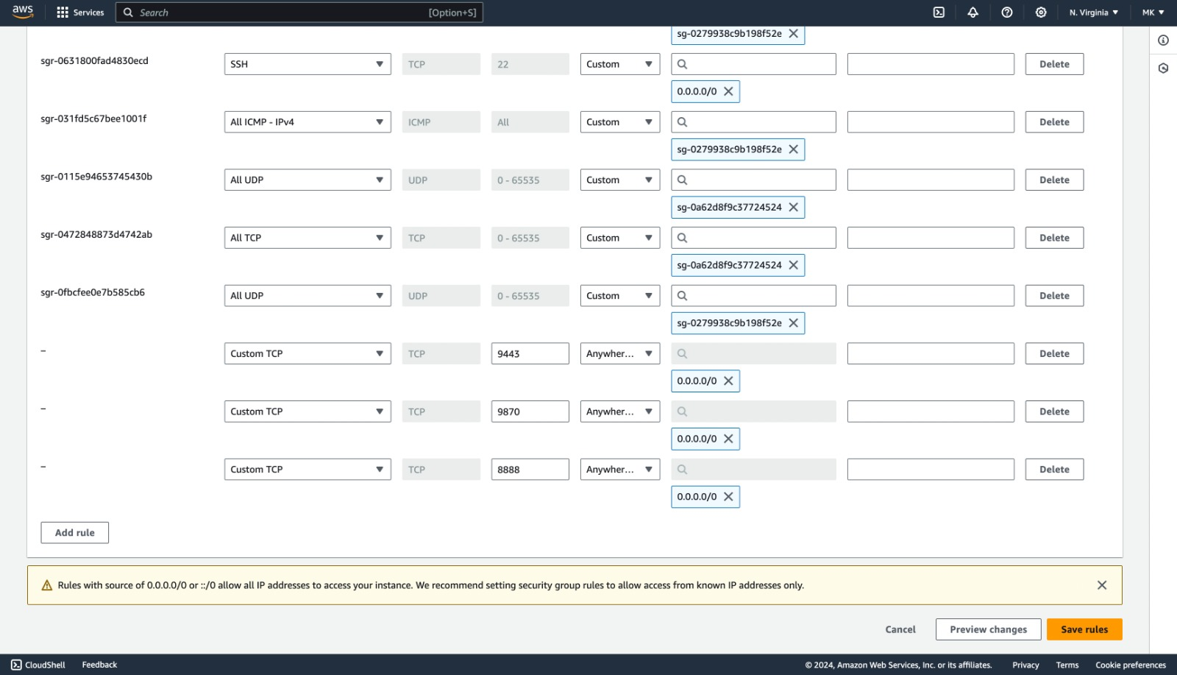

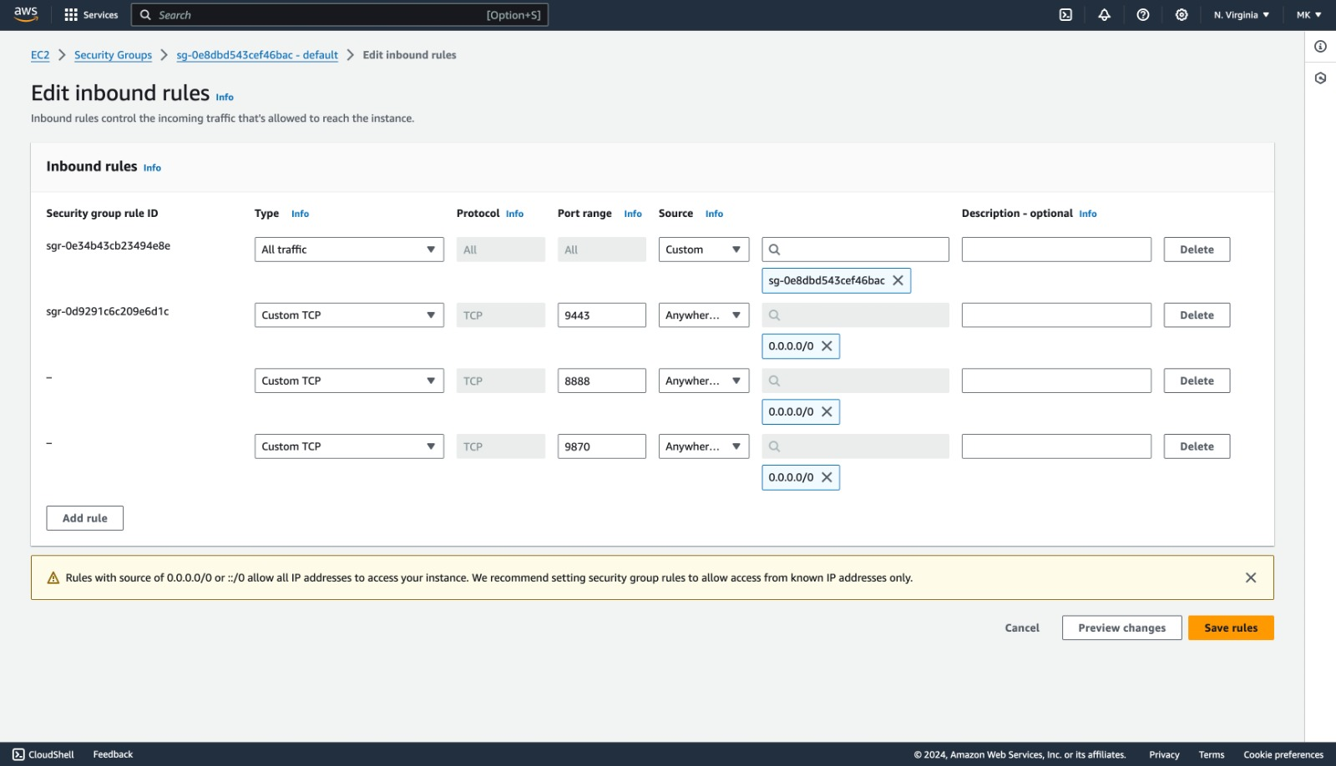

To Access JupyterHUB, navigate to URL under applications tab and enter defualt username and password

**username**: jovyan

**password**: jupyter

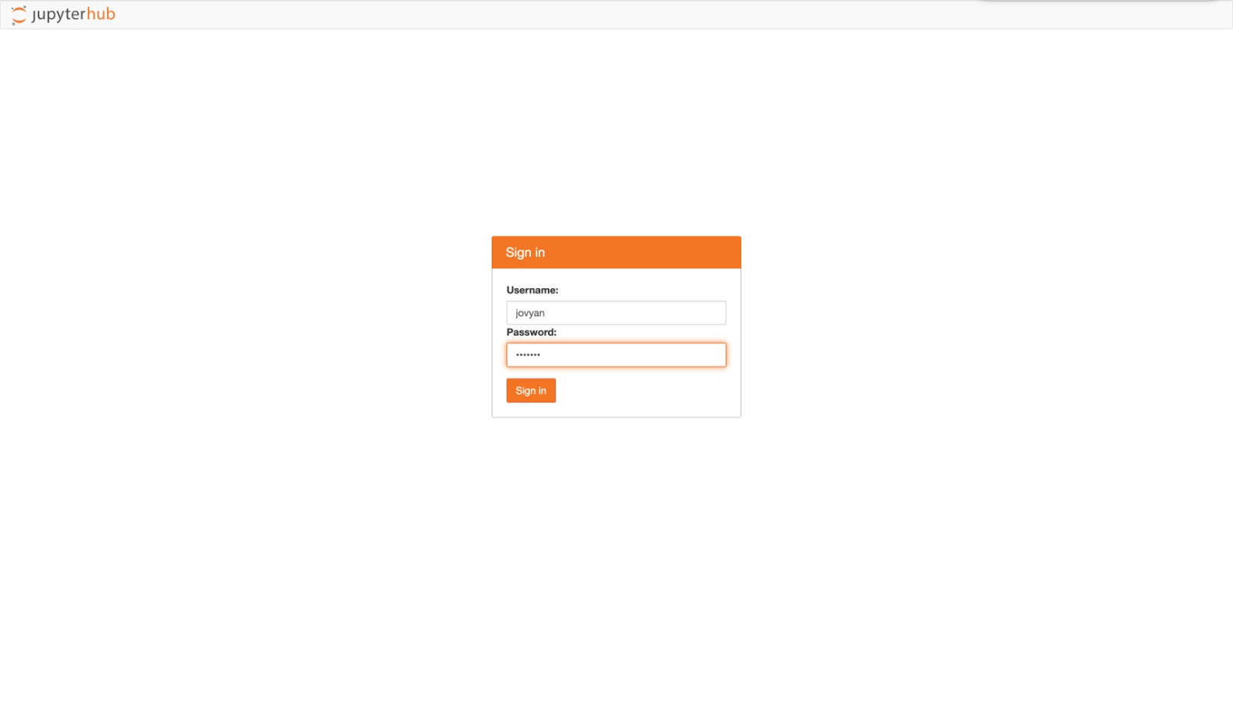

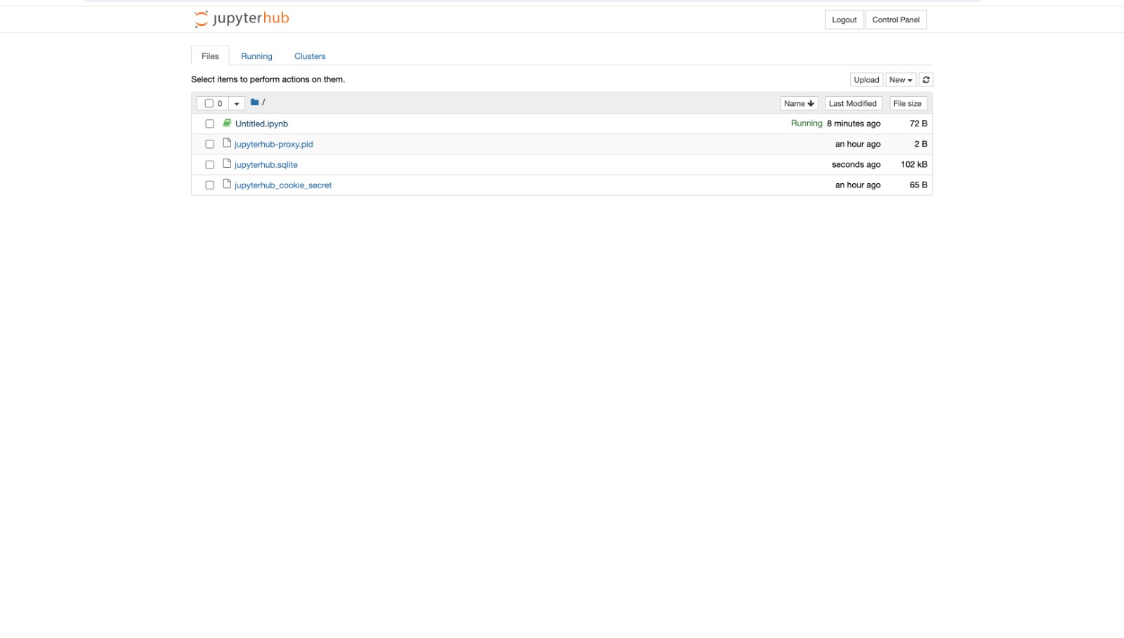

Results:

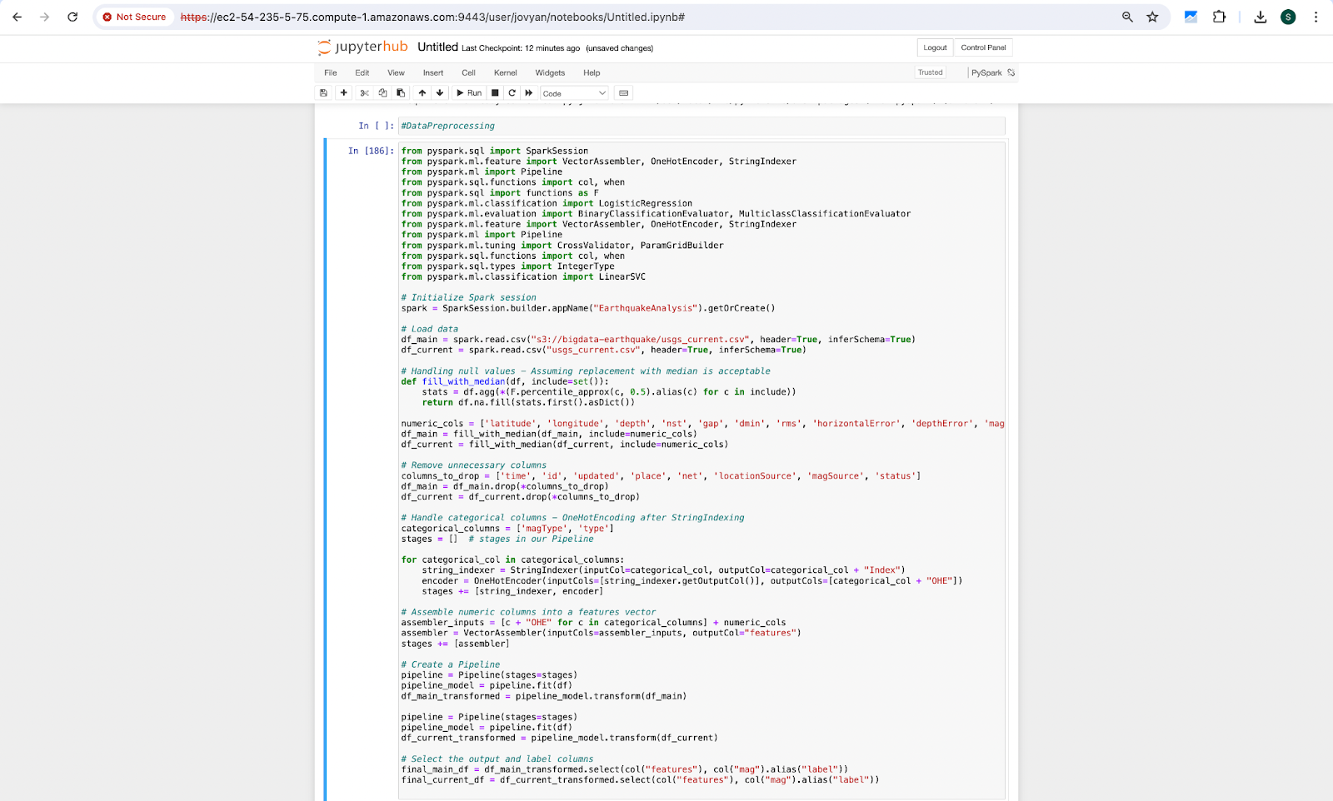

Linear Support Vector

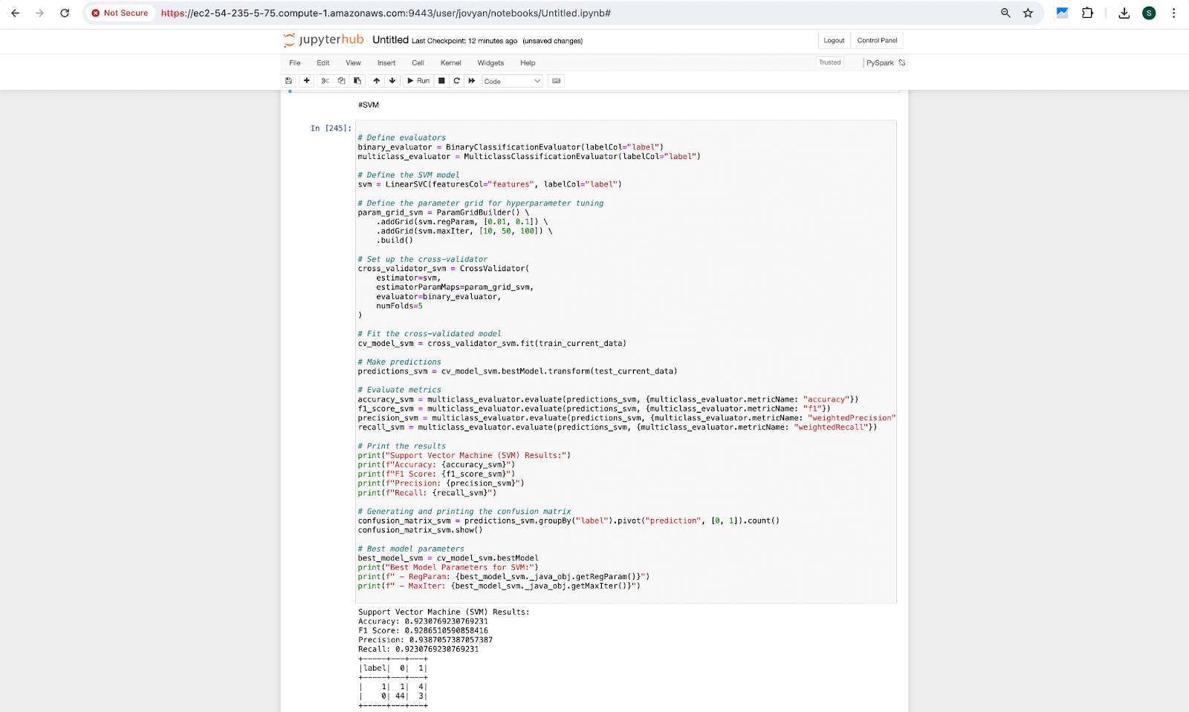

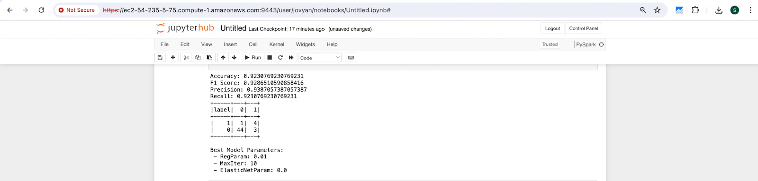

Logistic Regression

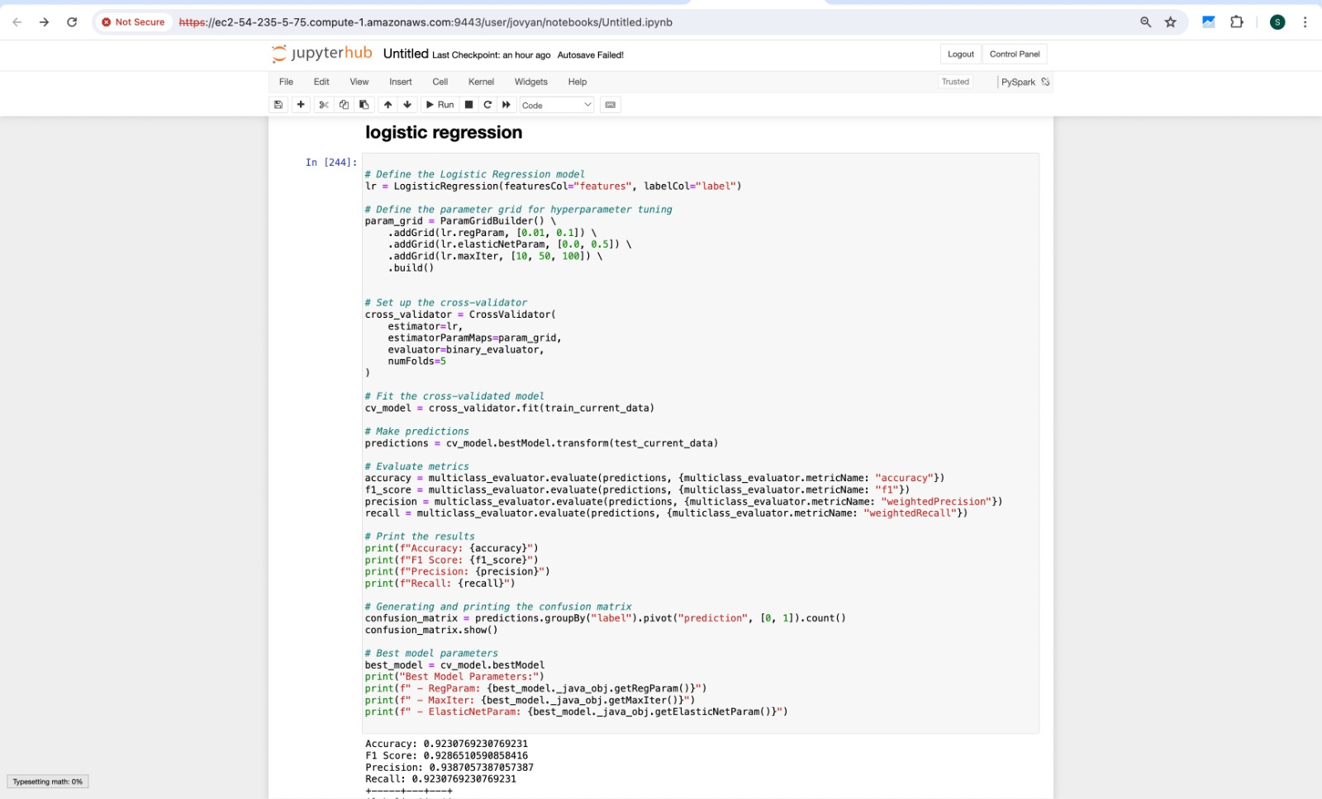



Decision Tree

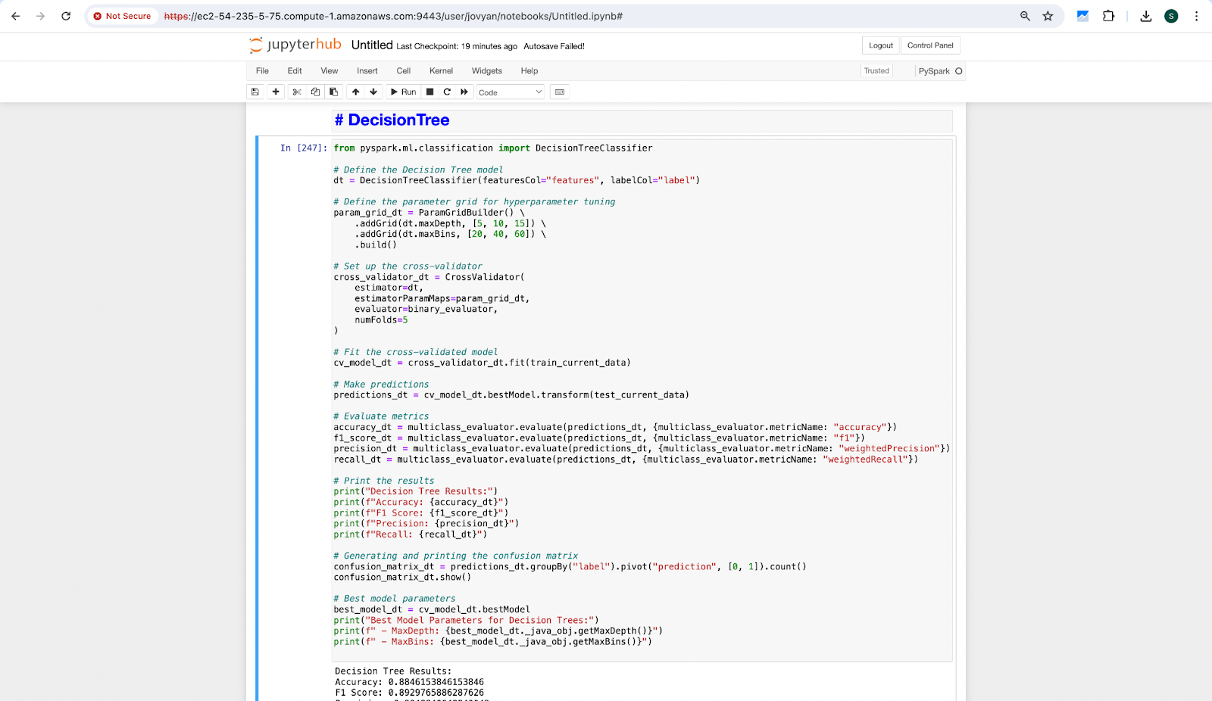

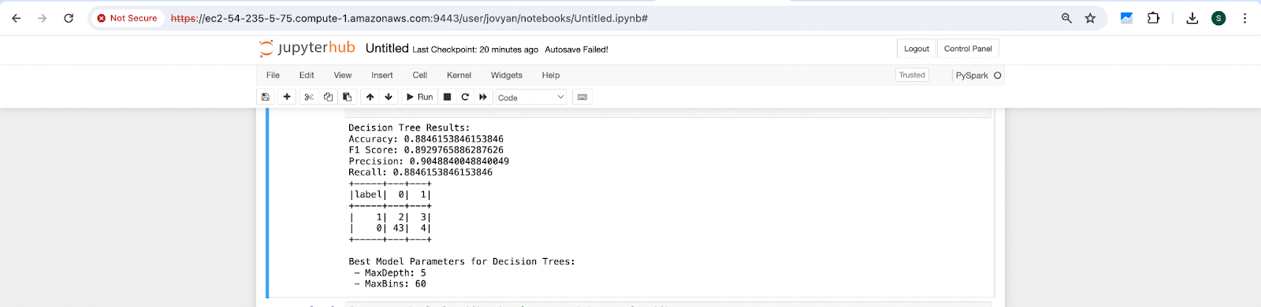

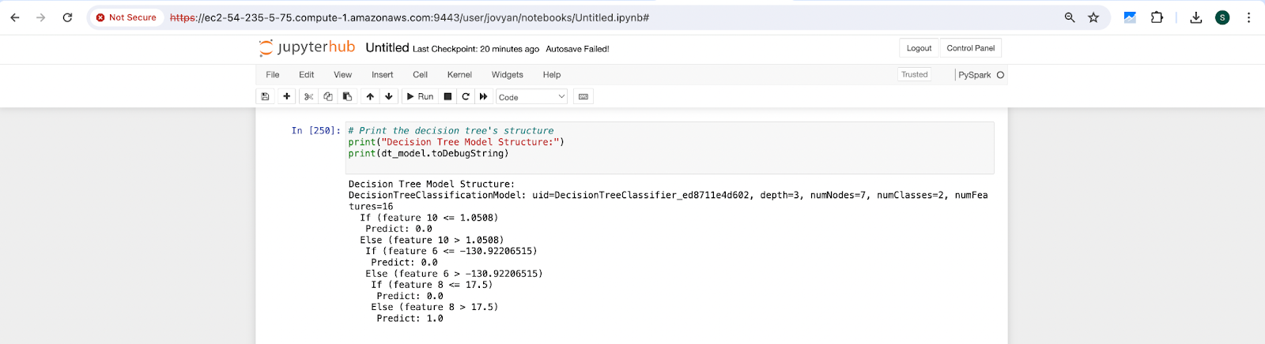

Random Forest

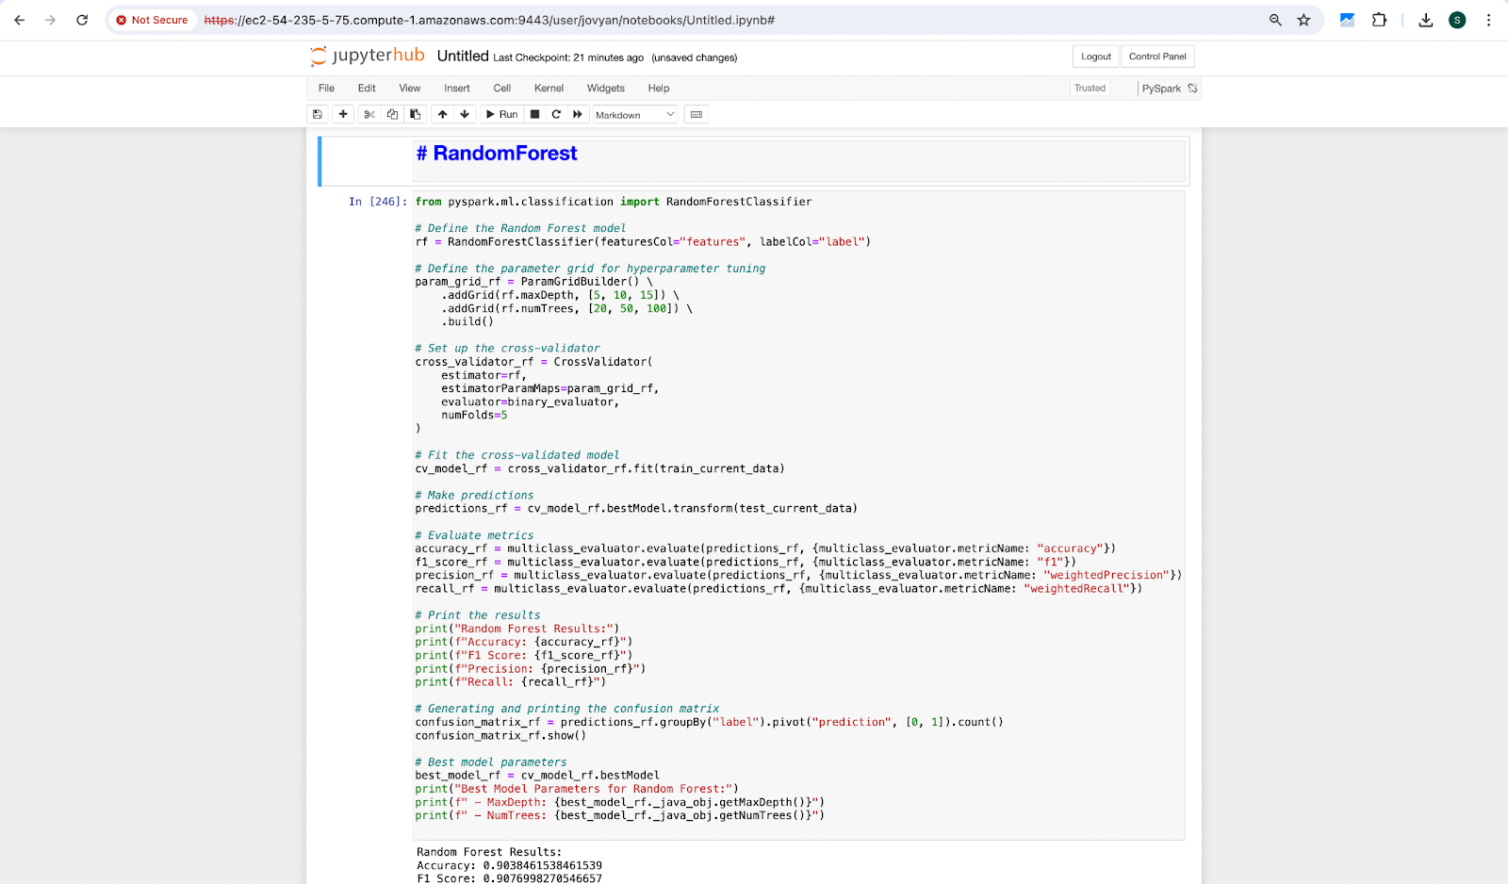

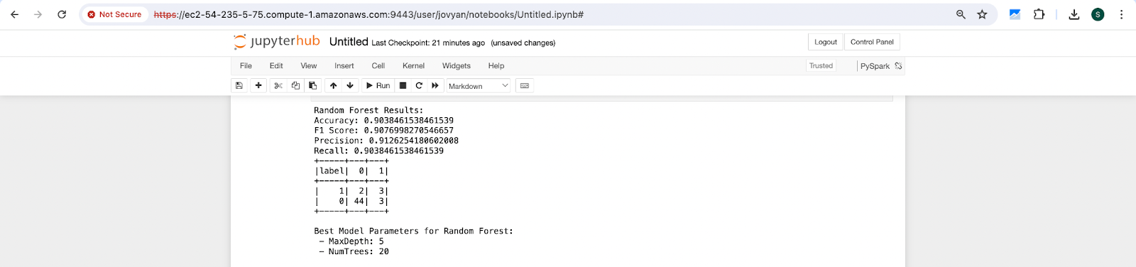

Feature Importances

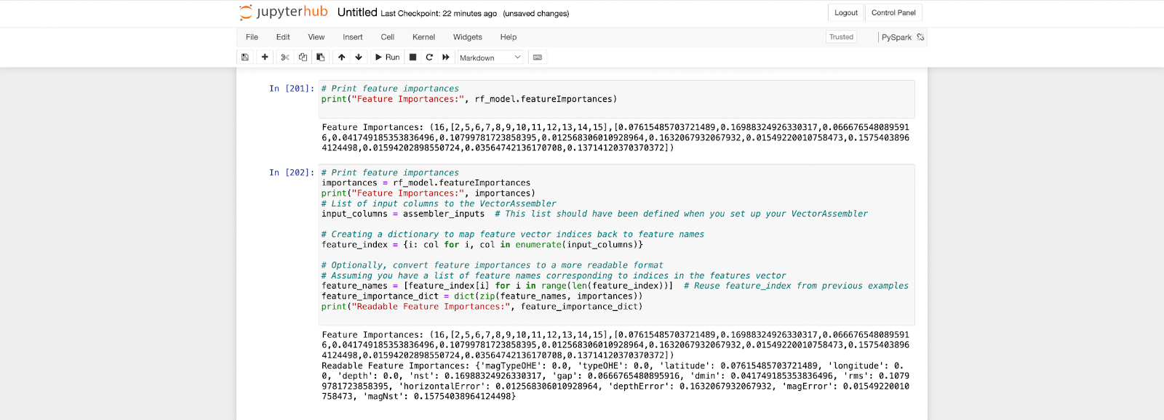

**Prediction Plots:**

Linear Regression

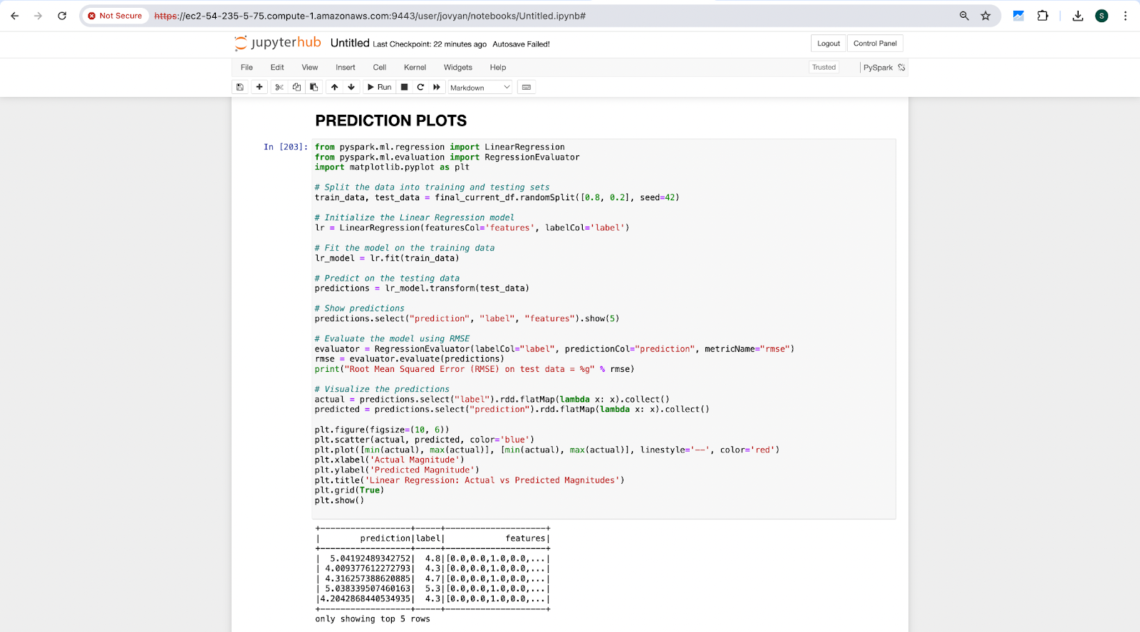

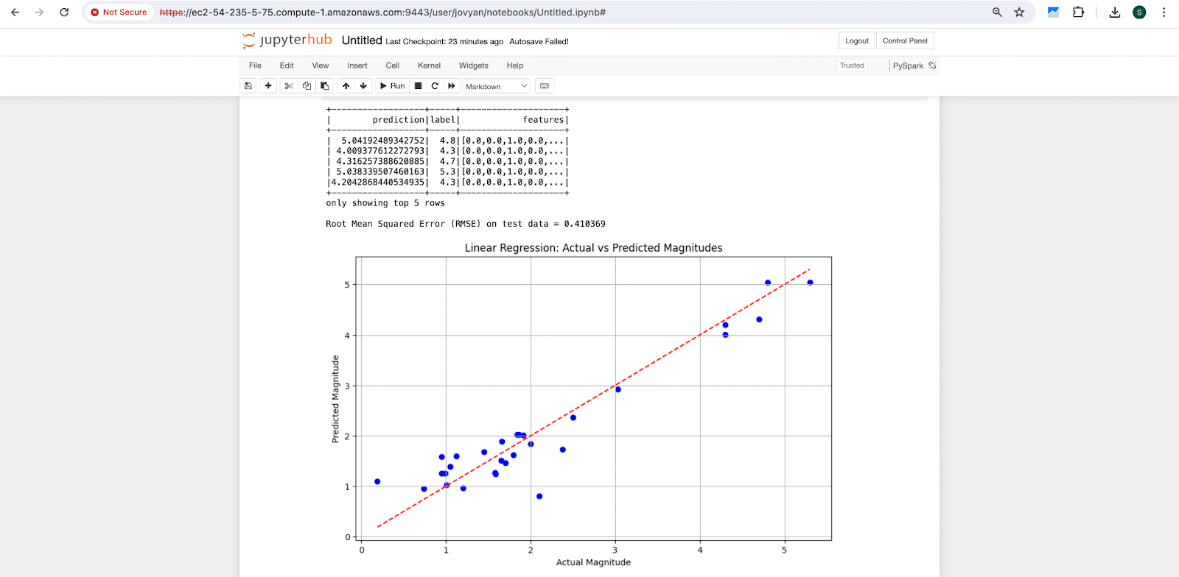

Random Forest:

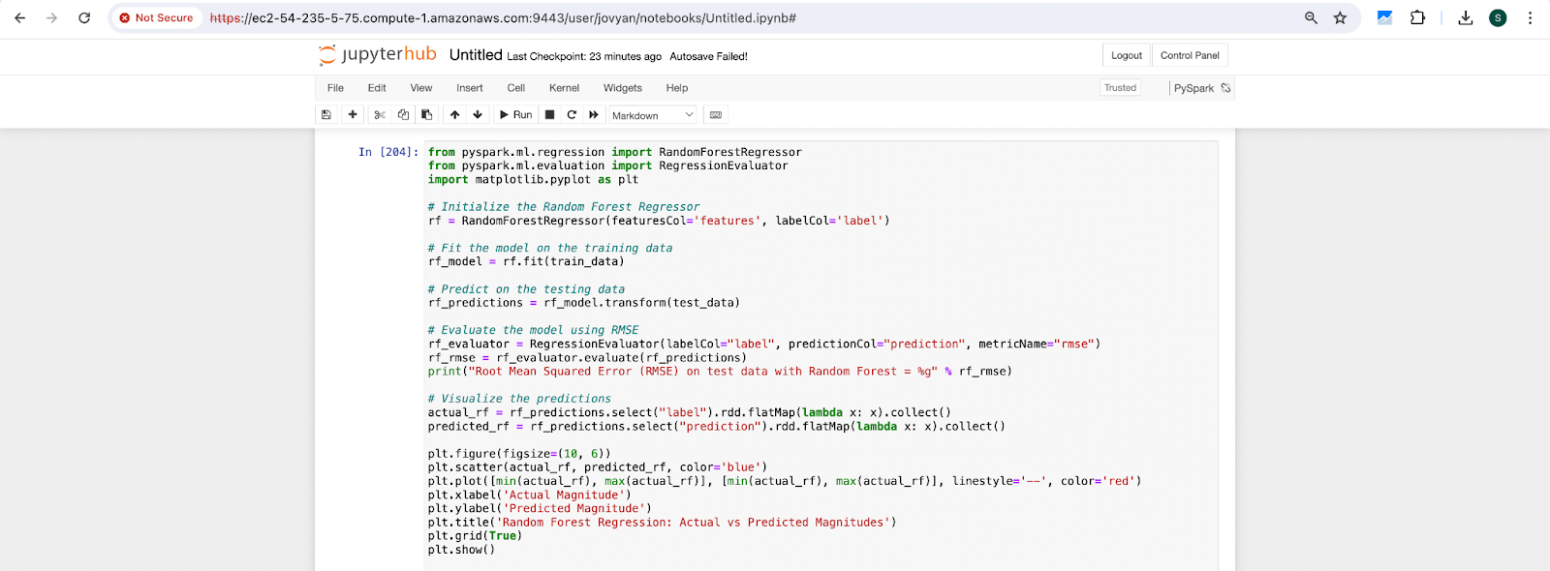

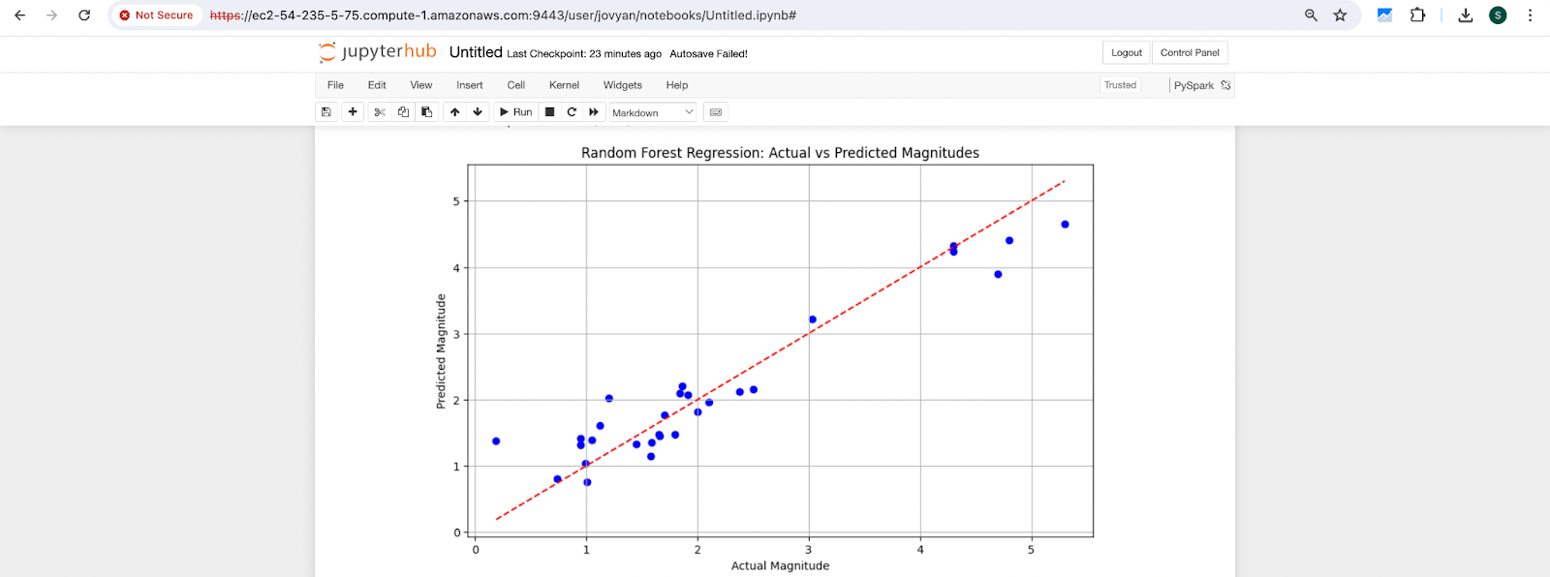

Data Visualization:

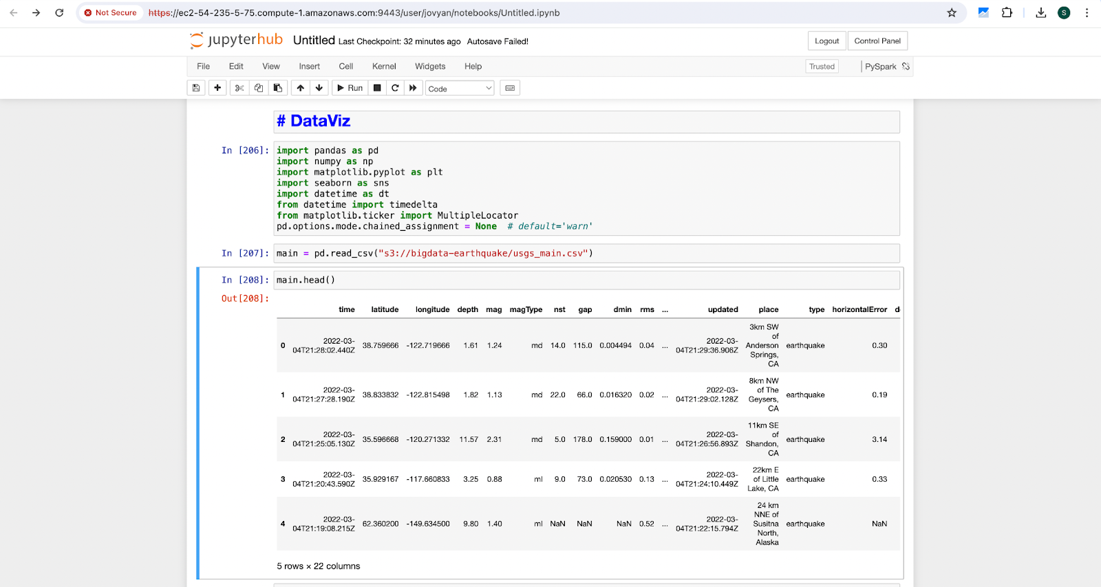

Box Plot:

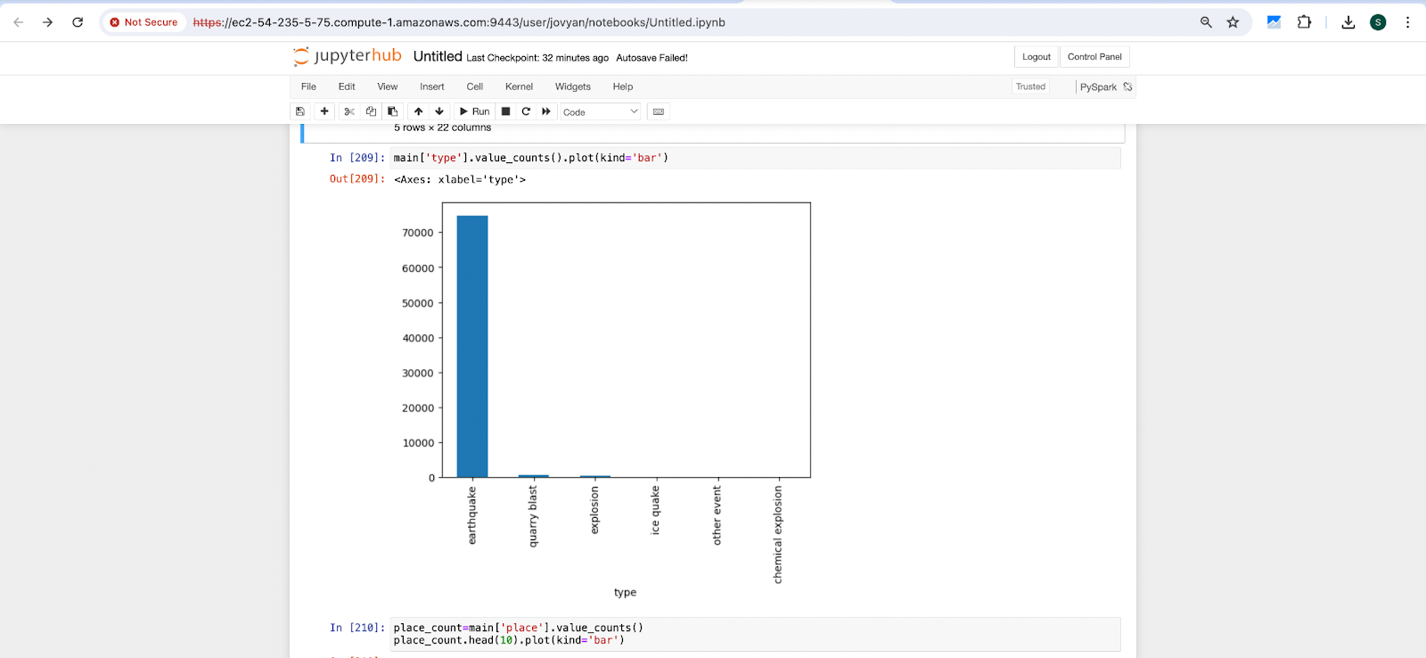

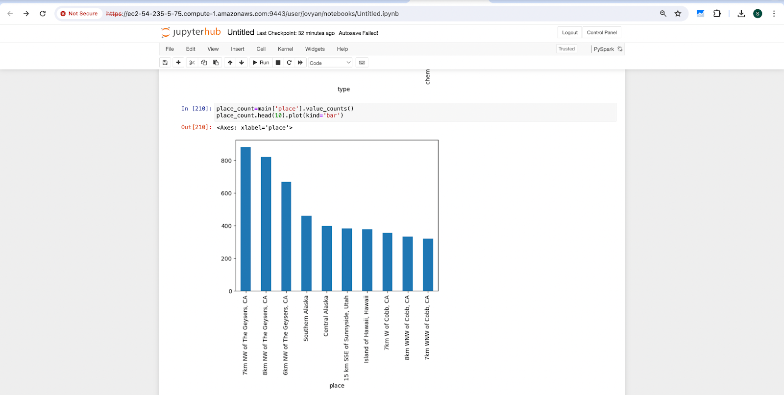

Scatter Plot:

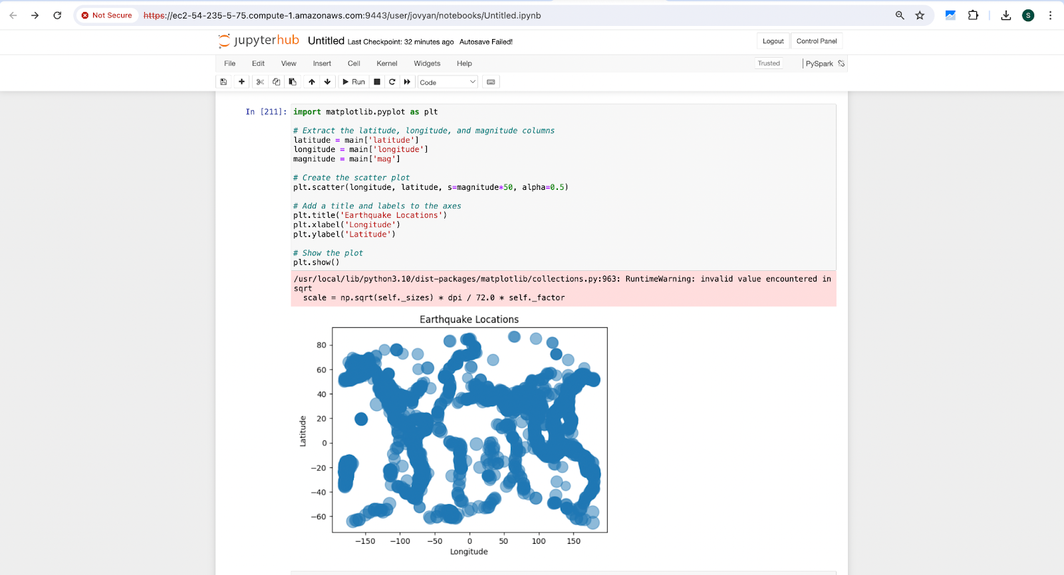

Line Plot:

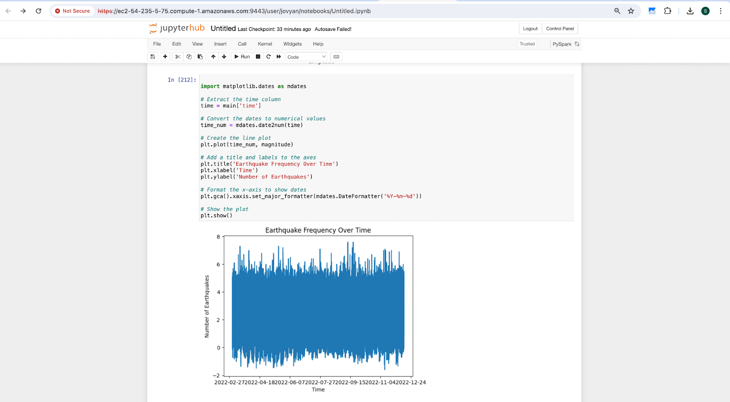

Colorbar:

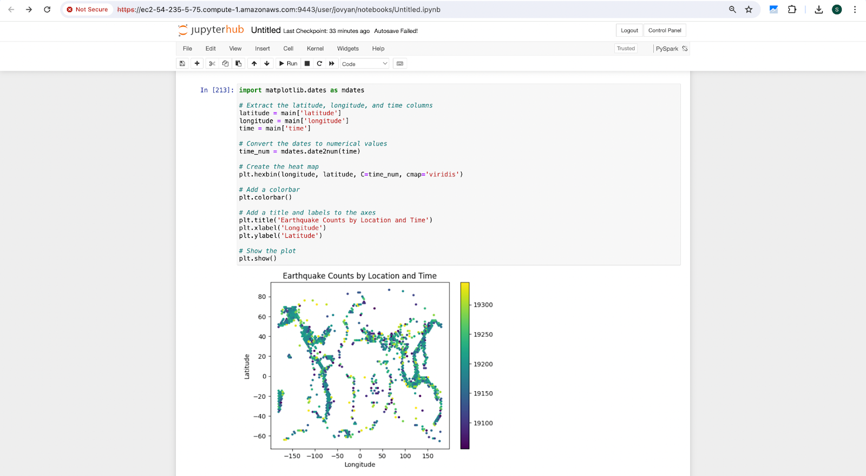

End Results:

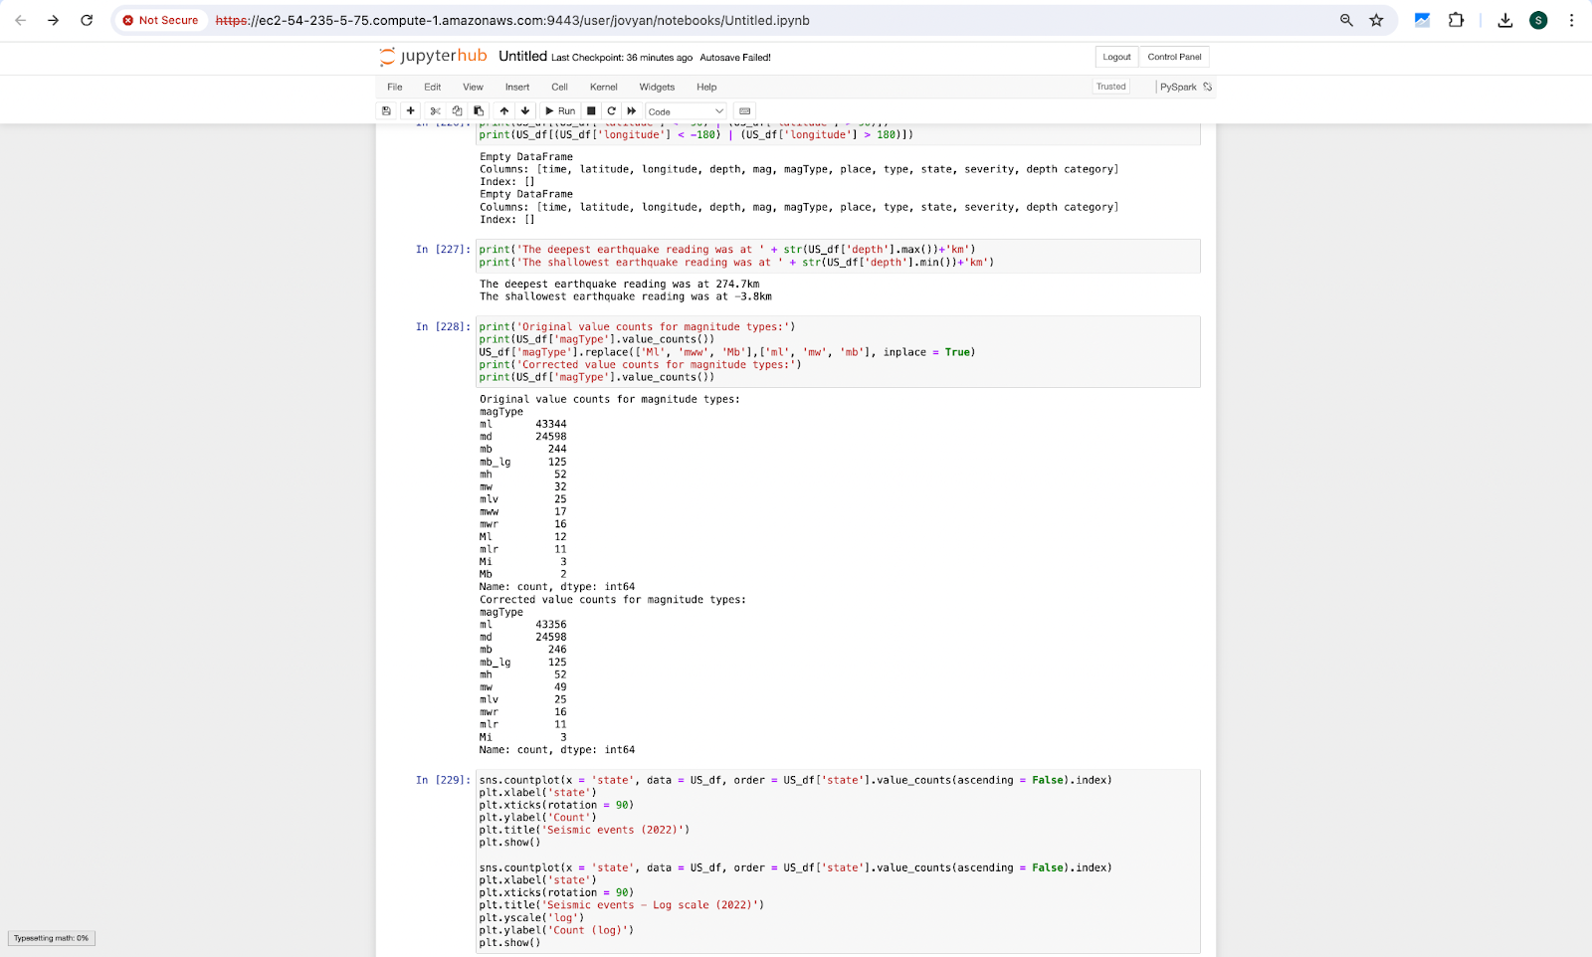

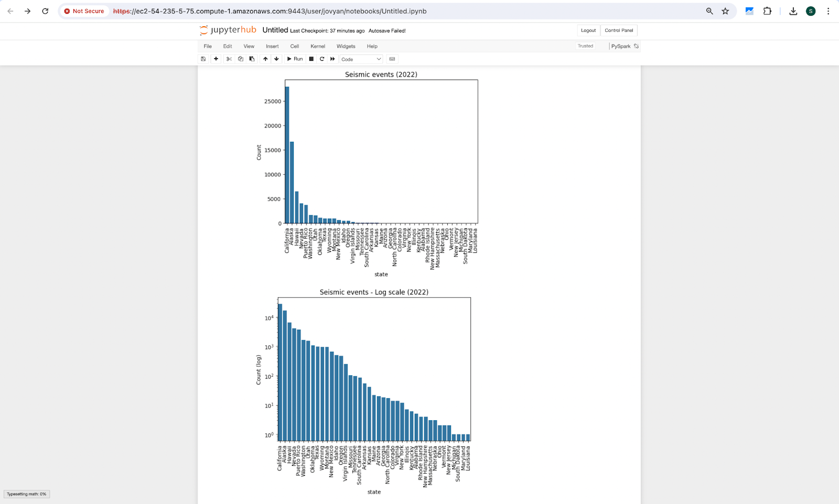

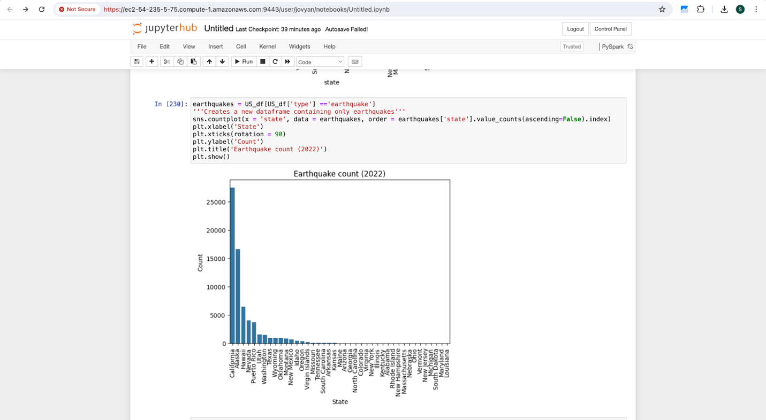

States with moderate earthquake

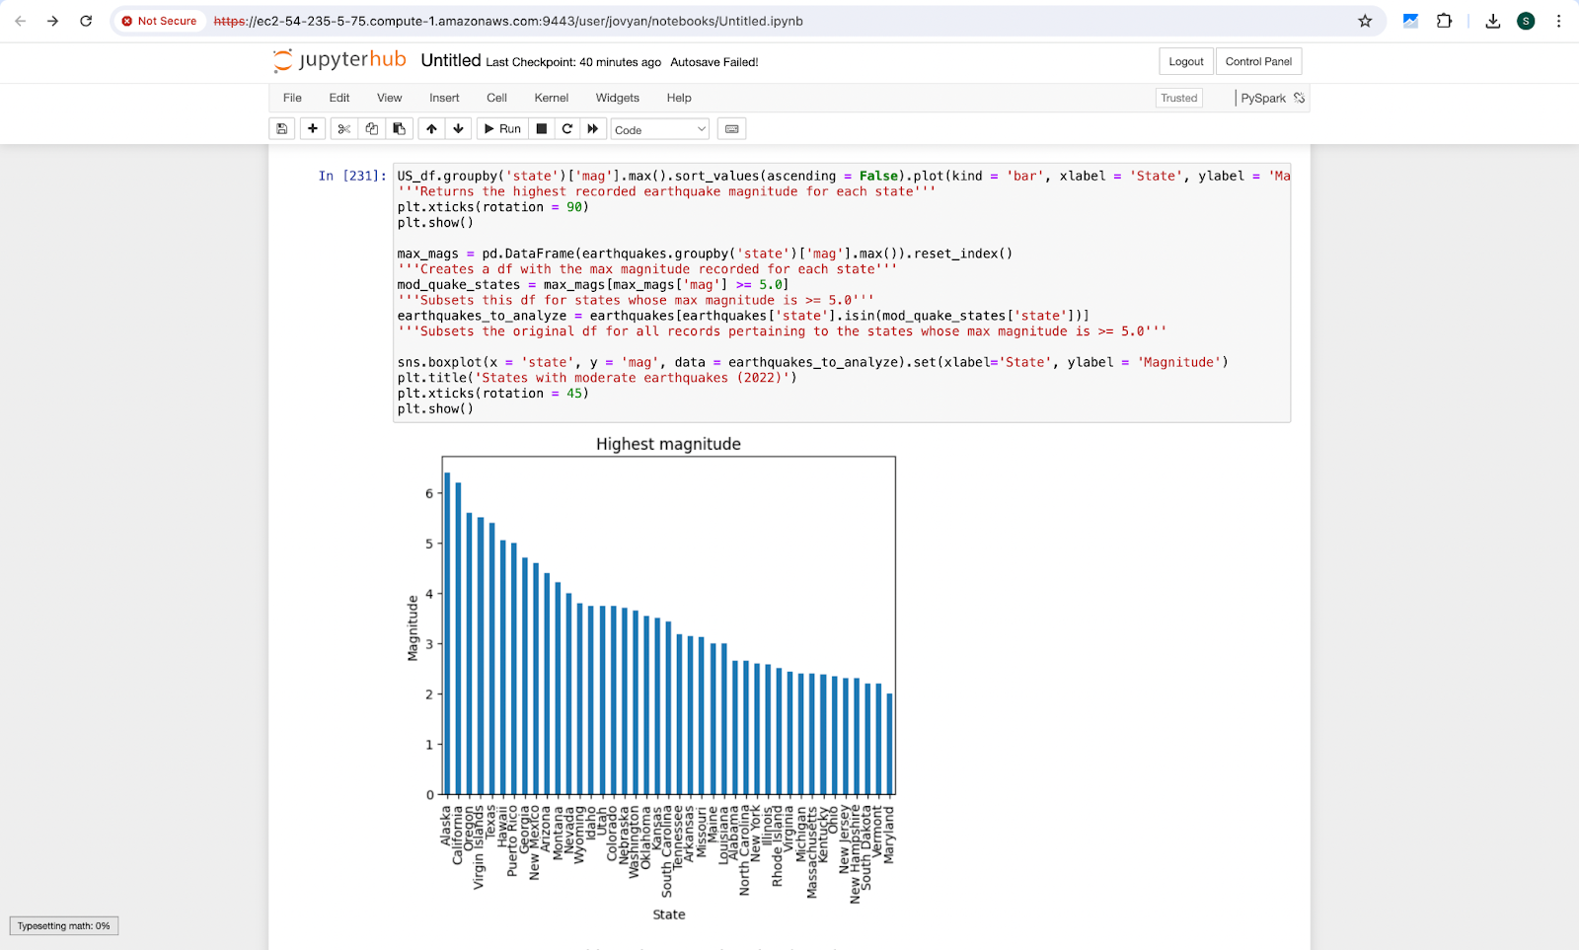

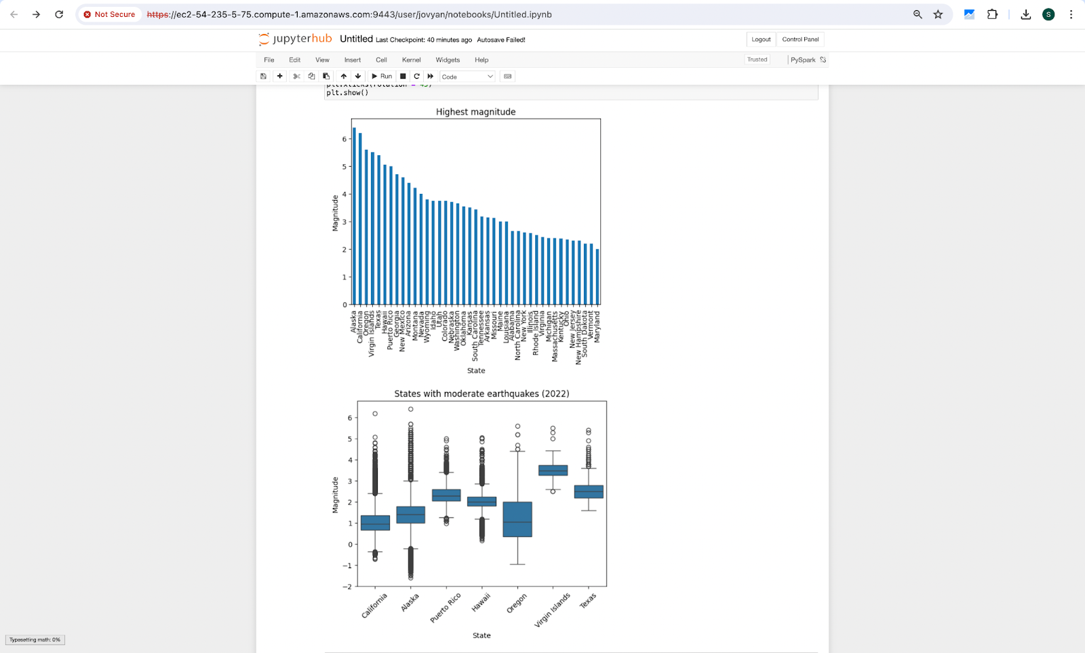

Damage Causing Eartquakes:

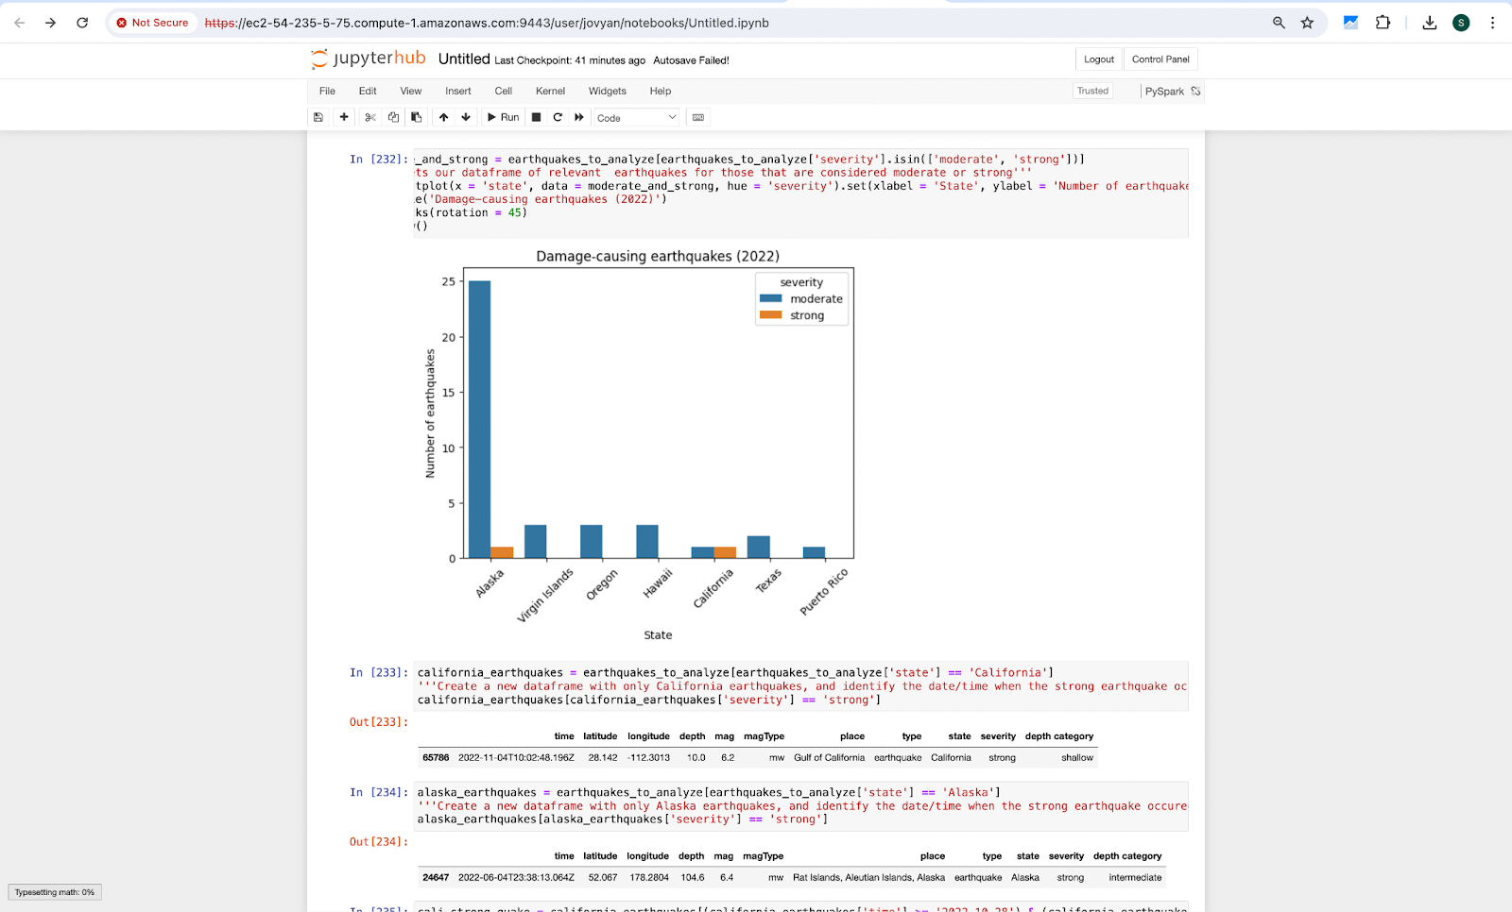

California Earthquakes:

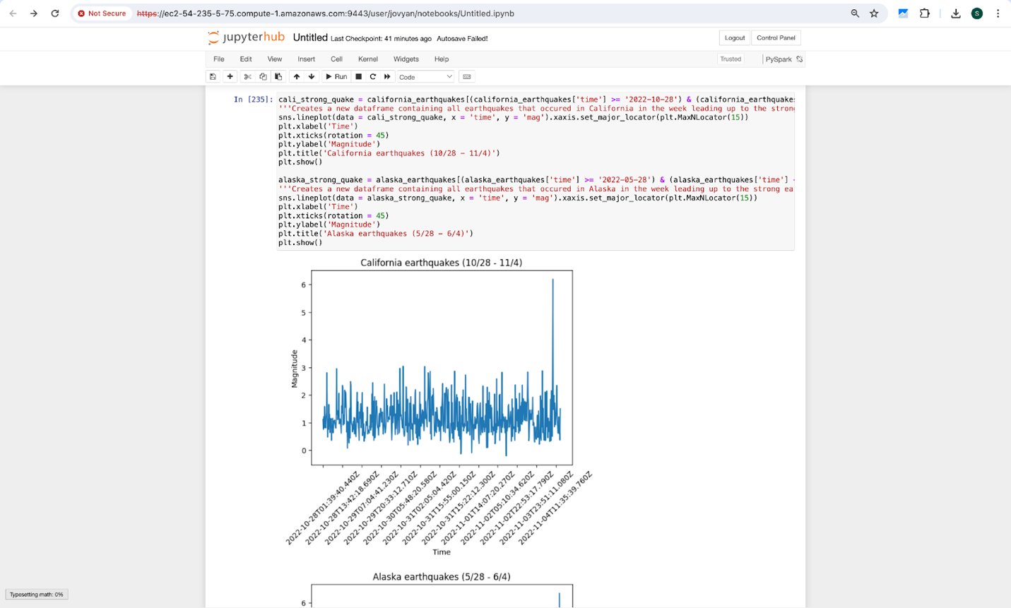

Alaska Earthquakes:

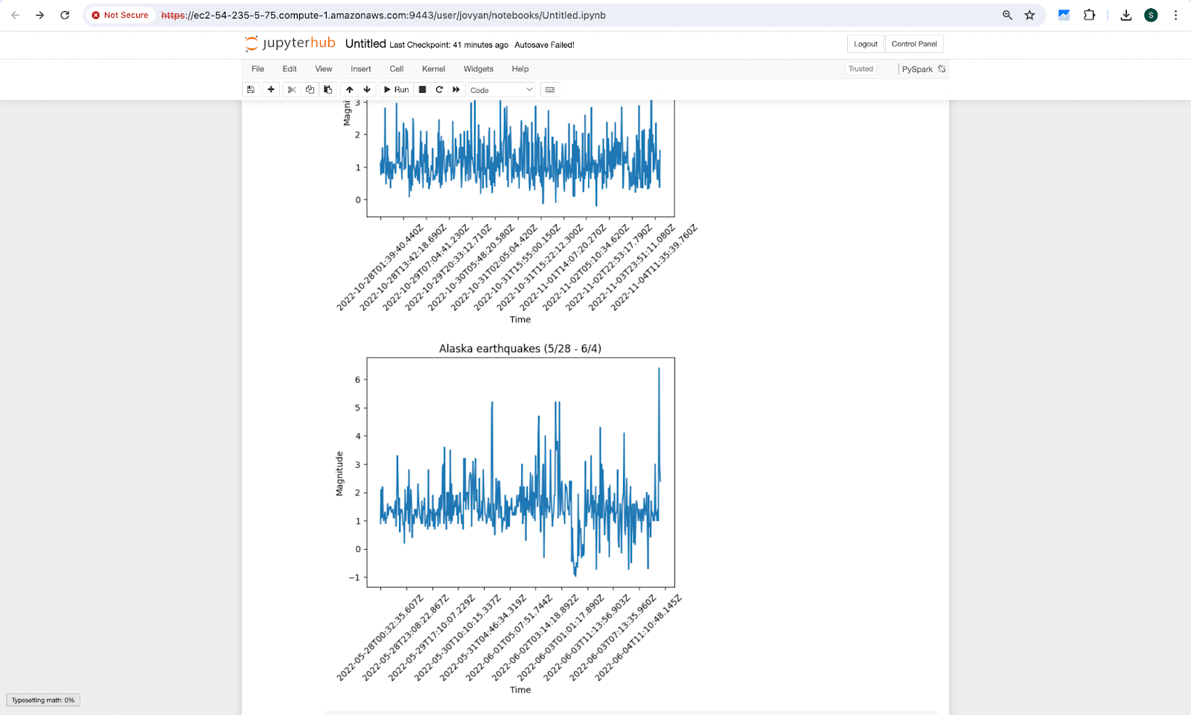

California Seismic Events:

